Online ArcGIS is used to generate the visualization. As this is an online tool, we can not download any source code.

In total 6 maps and one dashboard are created.

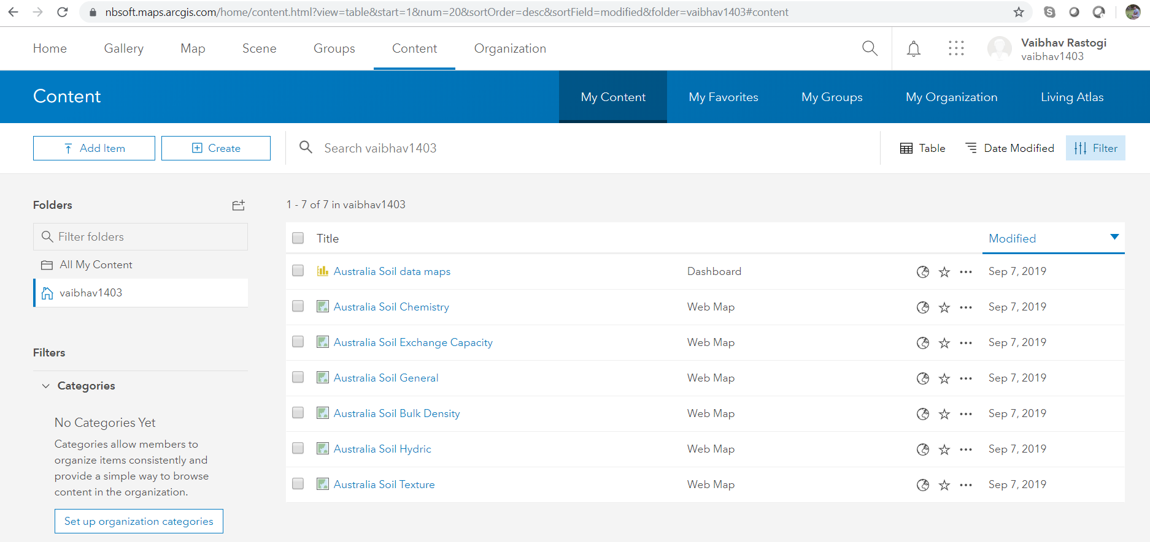

Below mentioned dashboard is created in ArcGIS online. 4 maps were added to this dashboard.

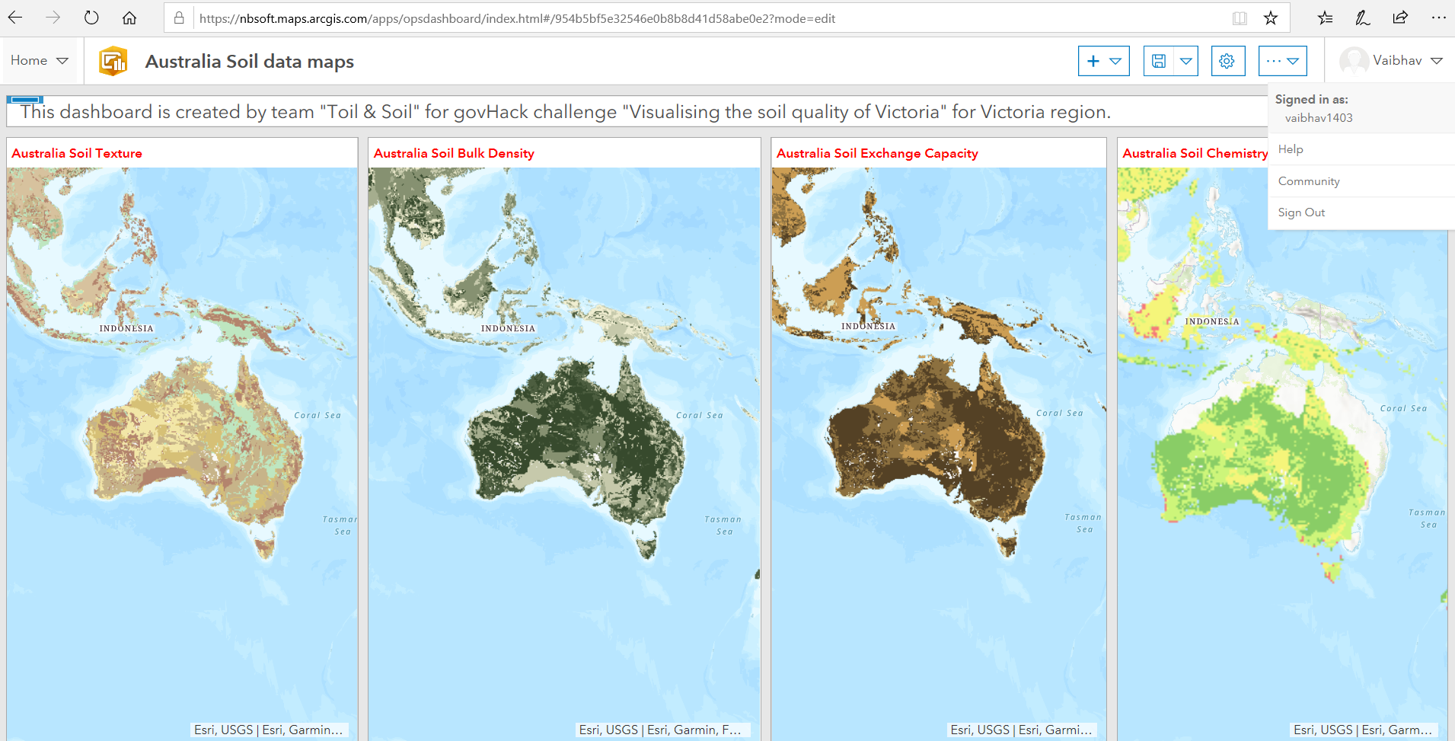

Various parameters can be viewed by clicking on the coordinate on each of these maps

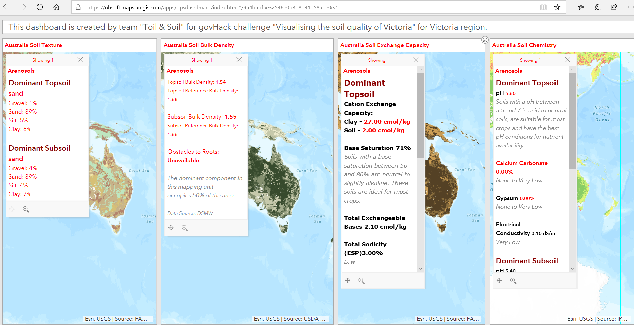

Below is the editable map image of “Australia Soil Chemistry”

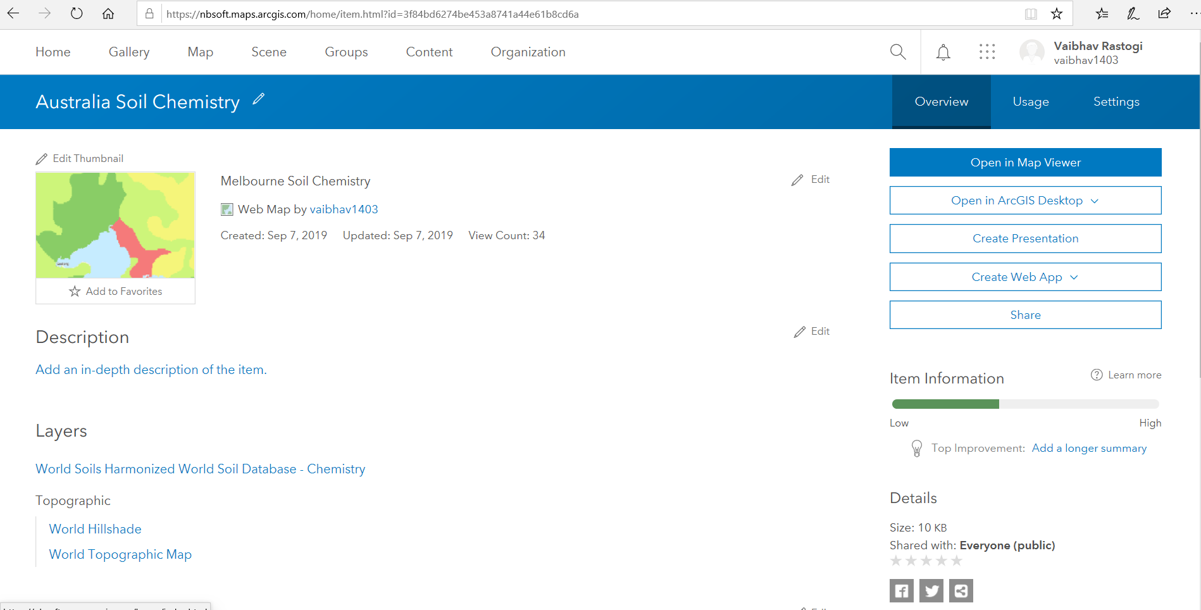

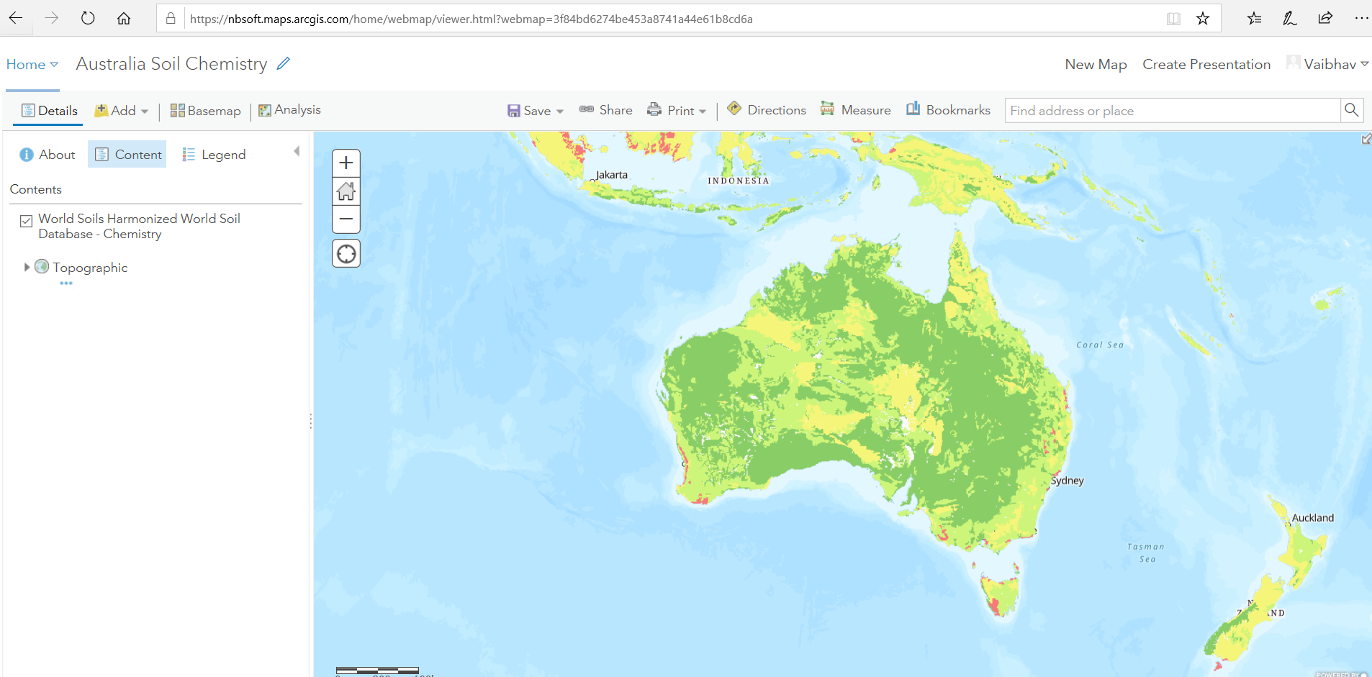

Below is the editable image of “Australia Soil Exchange Capacity”

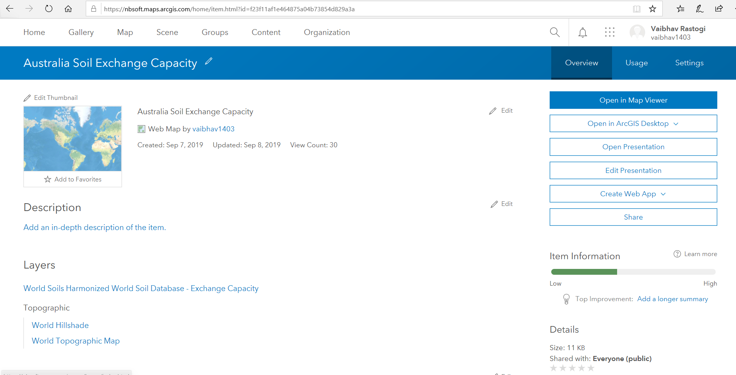

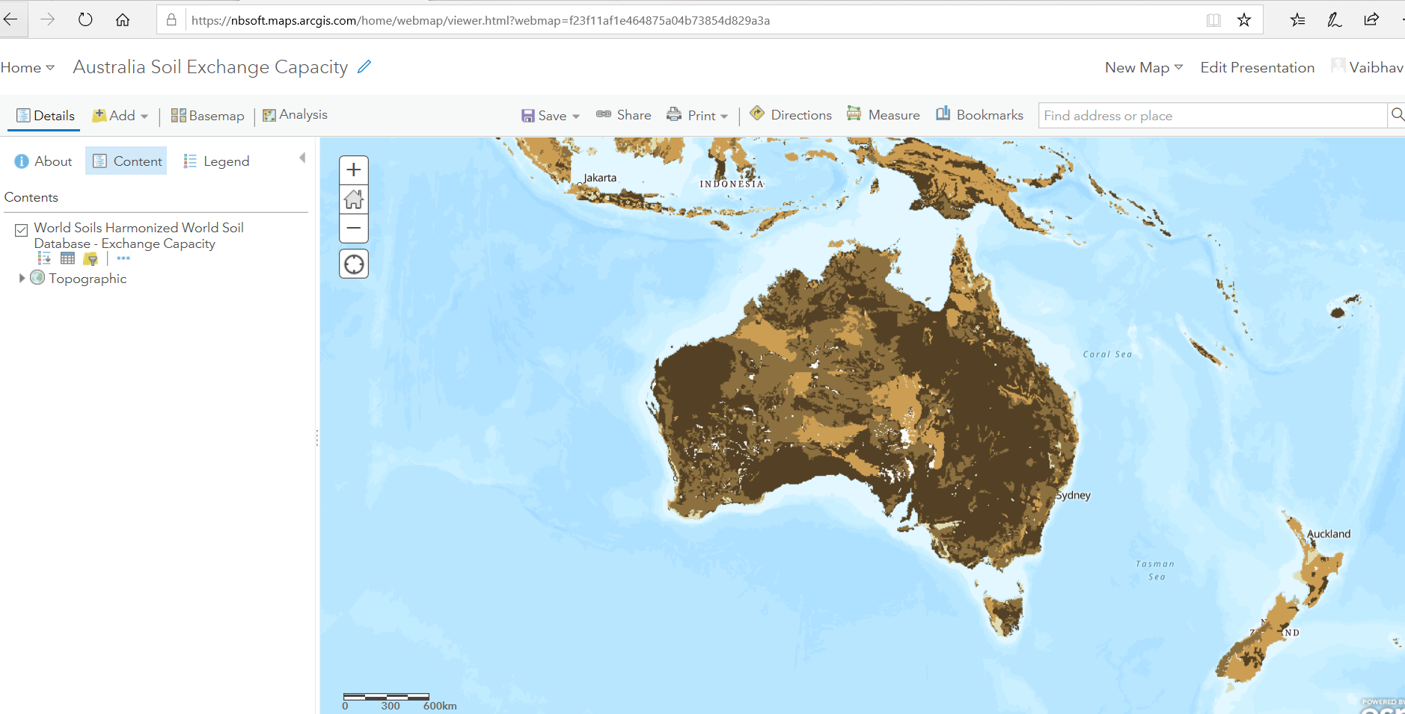

Below is the editable image of “Australia Soil Bulk Density”

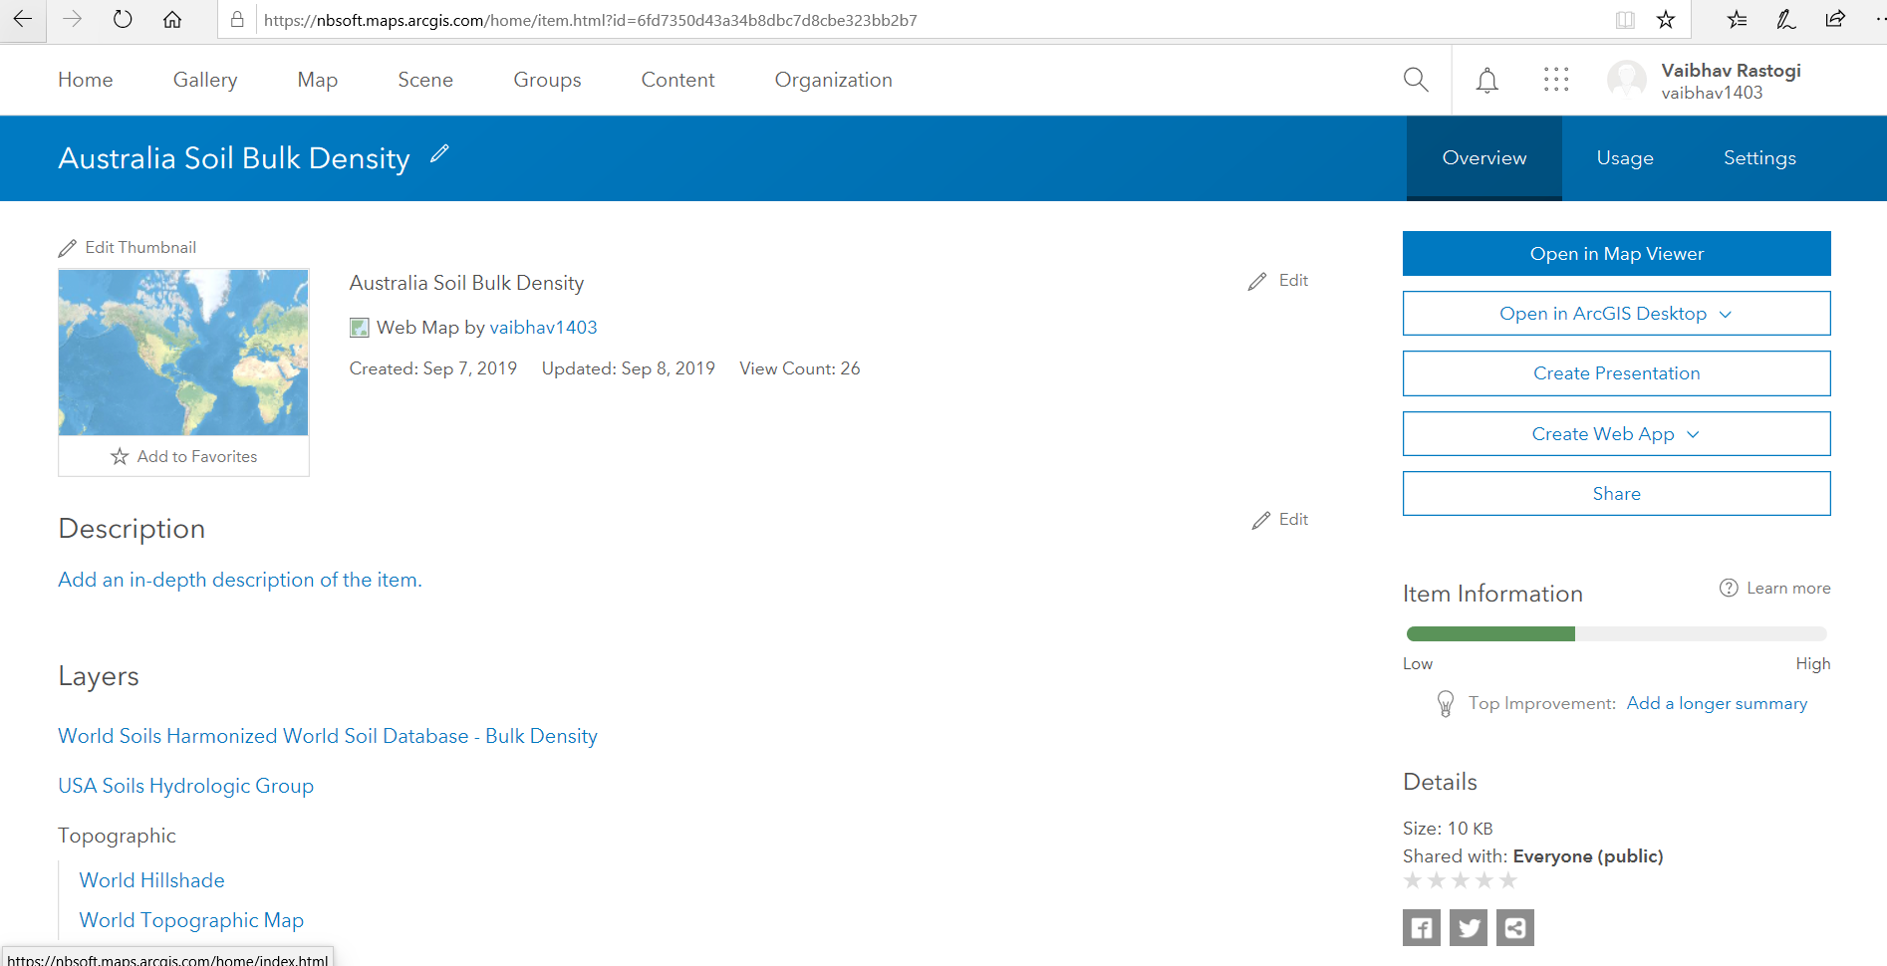

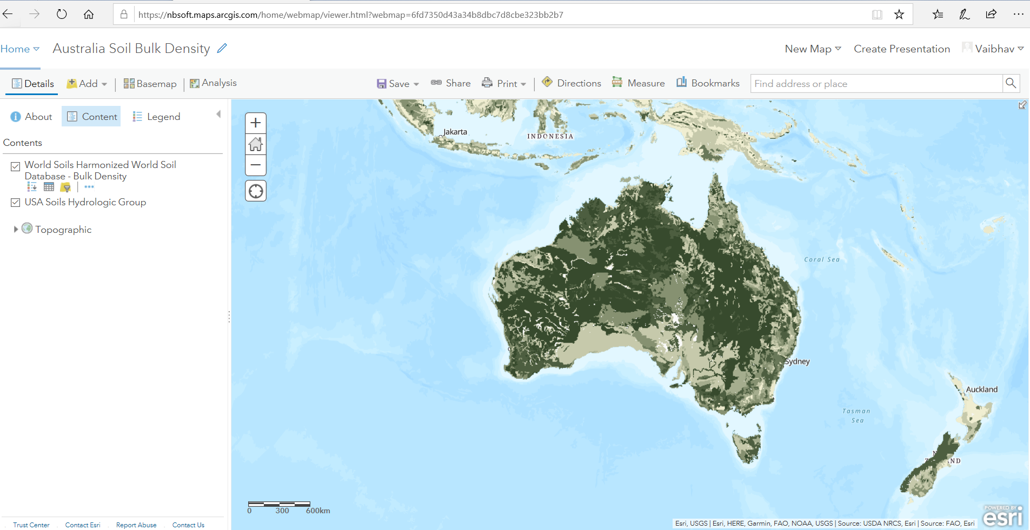

Below is the editable image of “Australia Soil Texture”

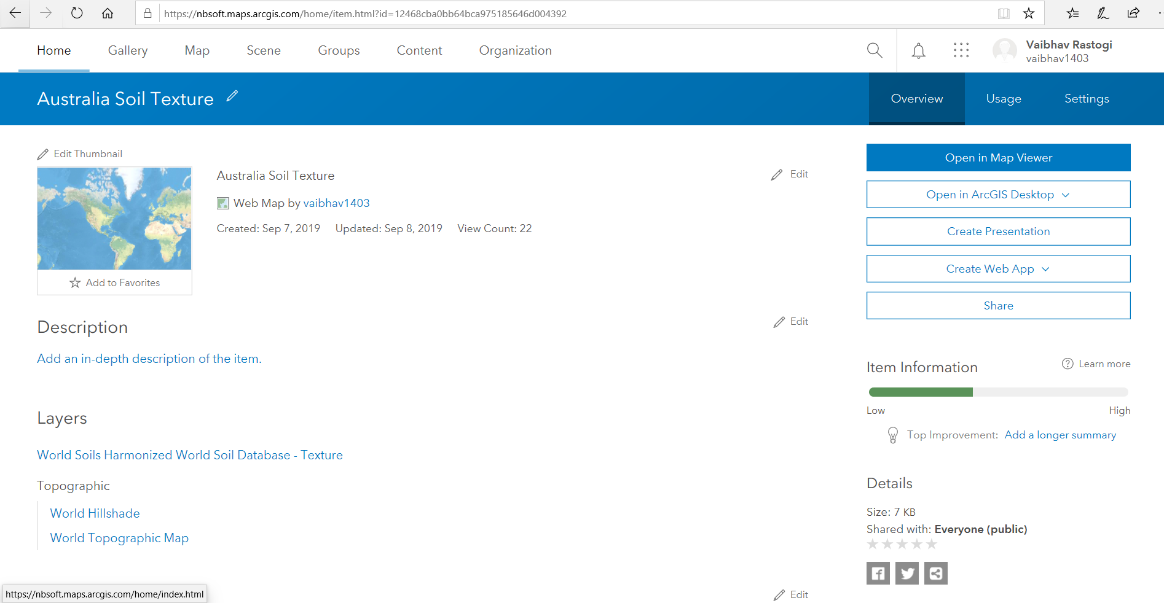

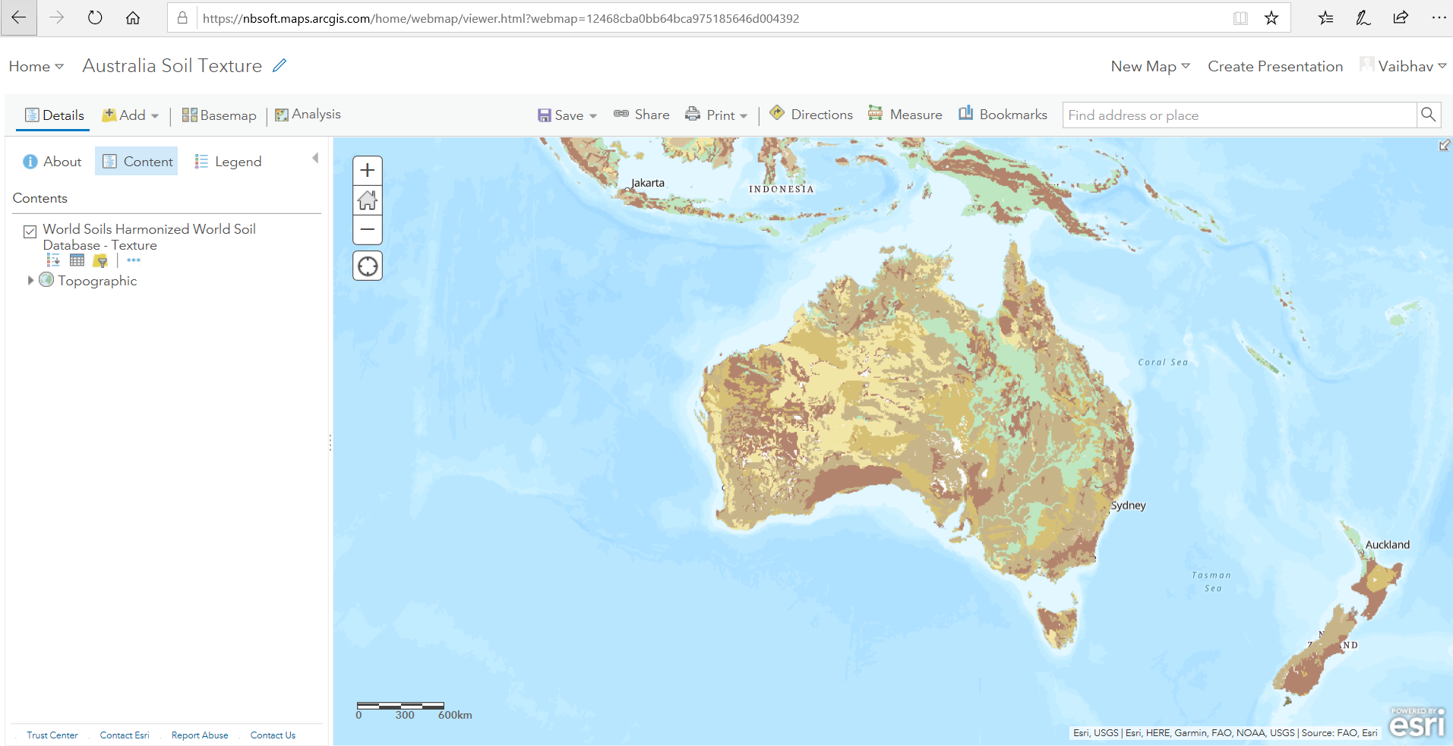

Postman tool is used to test the API

<https://api.vic.gov.au:443/avr/soils-api/v1.0/estimates?wgs84_east=145.937310&wgs84_north=-38.245853>

